21.105: a) For a rod in general of length 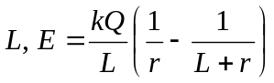 and here 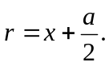
So, 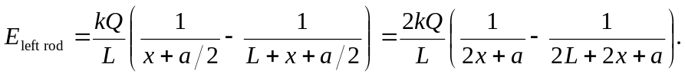
b) 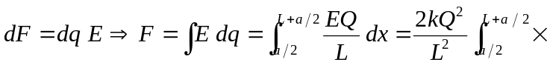
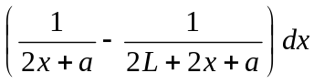
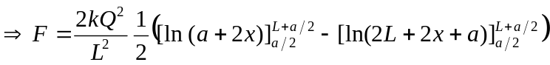
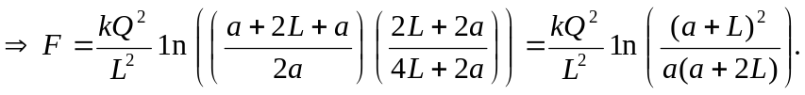
c) For 